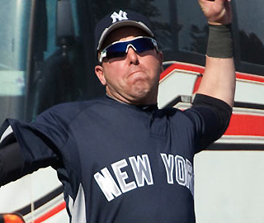
Rule 5 pick Hoffmann returned by Yanks
Outfielder clears outright waivers,
will go back to Dodgers

By Bryan Hoch / MLB.com
03/22/10 5:34 PM ET
CLEARWATER, Fla. -- The Yankees announced Monday that Rule 5 Draft selection Jamie Hoffmann cleared outright waivers and will be returned to the Dodgers.
Hoffmann, a 25-year-old outfielder, was acquired from the Nationals in December as the player to be named later in a trade for right-handed reliever Brian Bruney.
Considered in competition with non-roster invitee Marcus Thames to serve as New York's 25th man and a right-handed bat off the bench, Hoffmann hit .130 (3-for-23) in 11 Grapefruit League games for the Yankees this spring.
"It's a kid that we believe has tools," manager Joe Girardi said. "He went about his business the right way. His effort was tremendous. The numbers didn't translate."
Hoffmann played in an intrasquad game at George M. Steinbrenner Field on Monday morning, facing Andy Pettitte and Joba Chamberlain, before the transaction became official.
As a Rule 5 Draft pick, Hoffmann would have had to stay on the Yankees' 25-man roster all season or be offered back to Los Angeles for half of the original $50,000 selection price.
"Will he be a good player? I believe he can be," Girardi said. "But right now we needed to make a tough decision, and the Dodgers wanted him back."
Hoffmann was rated by Baseball America as the top defensive outfielder in the Dodgers' Minor League system for four consecutive seasons (2005-08) and hit .184 (4-for-22) in 14 Major League games for Los Angeles in 2009.
Thames, 33, appears to be the front-runner to lock up an outfield spot off the bench. A .243 career hitter in eight Major League seasons with the Yankees, Rangers and Tigers, Thames entered Monday hitting .107 (3-for-28) in spring action for New York.
Greg Golson and David Winfree are the other remaining right-handed-hitting outfielders in camp. Jon Weber, a non-roster invitee, is leading the club with a .571 batting average (12-for-21), but he is left-handed and thus has little chance of making the team.
We still have guys in camp that we're looking at," Girardi said. "As I've said all along, Marcus has the most experience in that situation against left-handers and has a proven track record. We'll continue to evaluate the other guys."

